CHEM 1021 — Exam 3 Practice Test
Day 2 of 7
Date: ______________________ Score: ________ / 100
Instructions: 25 multiple-choice questions, 4 points each. Choose the single best answer. Give yourself 50 minutes. Use only the reference information below, a periodic table, and a calculator. Fill in the answer sheet on the last page, then grade with the Day 2 Answer Key.
Reference Information
Equations and constants: Molarity = moles solute ÷ liters of solution · M₁V₁ = M₂V₂ · Nₐ = 6.022 × 10²³ · 1 cm³ = 1 mL · 1 L = 1 dm³ · 0.3047 m = 1 ft
The 7 strong acids: HCl, HBr, HI, H₂SO₄, HNO₃, HClO₄, HClO₃. Strong bases: all soluble hydroxide salts.
Common polyatomic ions: ammonium NH₄⁺ · hydronium H₃O⁺ · hydroxide OH⁻ · cyanide CN⁻ · carbonate CO₃²⁻ · phosphate PO₄³⁻ · chlorate ClO₃⁻ · bromate BrO₃⁻ · iodate IO₃⁻ · sulfate SO₄²⁻ · selenate SeO₄²⁻ · nitrate NO₃⁻ · acetate CH₃CO₂⁻
Acid naming: no oxygen → hydro- + root + -ic acid · -ate ion → -ic acid · -ite ion (one fewer O) → -ous acid · one more O than the -ate → per- + root + -ic acid · one fewer O than the -ite → hypo- + root + -ous acid
Activity Series (most → least active; a metal displaces any metal ion listed below it)
Group | Metals | Reacts with
1 | K, Ba, Sr, Ca, Na | Cold water, steam, and acids (produce H₂)
2 | Mg, Al, Mn, Zn, Cr, Fe, Cd | Steam and acids (produce H₂)
3 | Co, Ni, Sn, Pb | Acids only (produce H₂)
— | H₂ | —
4 | Sb, Bi, Cu, Ag, Hg, Pd, Pt | Do not react with water, steam, or acids
Electronegativity (main-group values)
Period | 1 | 2 | 13 | 14 | 15 | 16 | 17
1 | H 2.1
2 | Li 1.0 | Be 1.5 | B 2.0 | C 2.5 | N 3.0 | O 3.5 | F 4.0
3 | Na 0.9 | Mg 1.2 | Al 1.5 | Si 1.8 | P 2.1 | S 2.5 | Cl 3.0
4 | K 0.8 | Ca 1.0 | Ga 1.6 | Ge 1.8 | As 2.0 | Se 2.4 | Br 2.8
5 | Rb 0.8 | Sr 1.0 | In 1.7 | Sn 1.8 | Sb 1.9 | Te 2.1 | I 2.5
Solubility Rules
Ion | Rule | Exceptions
Na⁺, K⁺, NH₄⁺ | Salts with an alkali metal or ammonium ion are soluble | None
NO₃⁻, CH₃CO₂⁻ | All nitrates and acetates are soluble | None
SO₄²⁻ | Most sulfates are soluble | BaSO₄, SrSO₄, PbSO₄, CaSO₄, Hg₂SO₄, Ag₂SO₄
Cl⁻, Br⁻, I⁻ | Most chlorides, bromides, and iodides are soluble | AgX, Hg₂X₂, PbX₂, HgI₂
Ag⁺ | Silver compounds are generally insoluble | AgNO₃ and AgClO₄ are soluble; AgCH₃CO₂ is slightly soluble
O²⁻, OH⁻ | Oxides and hydroxides are insoluble | Alkali metal hydroxides, Ba(OH)₂, Sr(OH)₂; Ca(OH)₂ is somewhat soluble
S²⁻ | Sulfides are insoluble | Compounds with Na⁺, K⁺, NH₄⁺, and alkaline earth cations
CrO₄²⁻ | Most chromates are insoluble | Compounds with Na⁺, K⁺, NH₄⁺, Mg²⁺, Ca²⁺, Al³⁺, Ni²⁺
CO₃²⁻, PO₄³⁻, SO₃²⁻, SiO₃²⁻ | Most carbonates, phosphates, sulfites, and silicates are insoluble | Compounds with Na⁺, K⁺, NH₄⁺

1. Returning Topic: Report the answer to the following calculation with the correct number of significant figures:
(8.314 × 2.0) ÷ (0.500 + 12.31)
A. 1
B. 1.3
C. 1.30
D. 1.298
2. Returning Topic: How many cubic centimeters are there in 0.0350 cubic meters?
A. 3.50 × 10⁰ cm³
B. 3.50 × 10² cm³
C. 3.50 × 10⁴ cm³
D. 3.50 × 10⁶ cm³
3. Returning Topic: Consider the transition metal copper (Z = 29). How many d electrons are in the ground-state electron configuration of the Cu²⁺ ion?
A. 7
B. 8
C. 9
D. 10
4. Returning Topic: Which of the following is the correct electron configuration for a neutral copper (Z = 29) atom?
A. [Ar]3d¹⁰
B. [Ar]4s¹3d¹⁰
C. [Ar]4s²3d⁹
D. [Ar]4s²4d⁹
5. Lead forms the following compound with oxygen: PbO₂. What is the name of this compound?
A. lead(IV) oxide
B. lead dioxide
C. lead oxide
D. lead(II) oxide
6. Which of the following ions would form the strongest bond with an oxide ion, O²⁻?
A. Al³⁺
B. Mg²⁺
C. K⁺
D. Na⁺
7. Consider the compound P₄O₁₀. What is the correct name for this compound?
A. quadraphosphorus decoxide
B. tetraphosphorus decoxide
C. phosphorus(X) oxide
D. phosphorus oxide
8. The element zorium reacts with fluvine to form a compound with the name zorium trifluvide. Which of the following statements about this compound is correct?
A. The compound contains three times as many zorium atoms as fluvine atoms.
B. Fluvine is a metal.
C. Zorium is further right or above fluvine on the periodic table.
D. Zorium is a non-metal element.
9. Categorize the following compounds as ionic or covalent.
I: KNO₃ II: PCl₃ III: H₂O
A. I and II are ionic; III is covalent.
B. II is ionic; I and III are covalent.
C. I, II, and III are all covalent.
D. I is ionic; II and III are covalent.
10. Which of the following bonds is most polar? (Use the electronegativity table.)
A. C–F
B. N–O
C. S–O
D. P–Cl
11. What is the electron domain geometry on the atom X in the structure shown?
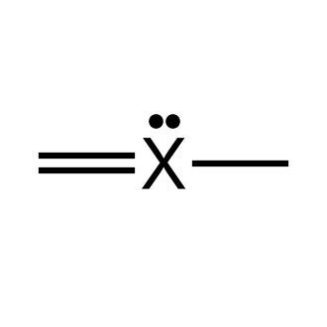
A. Trigonal planar
B. Tetrahedral
C. Trigonal pyramidal
D. Linear
12. Predict the molecular shape and the approximate bond angle of carbon dioxide.
A. Bent, 120°
B. Bent, < 109.5°
C. Linear, 180°
D. Trigonal planar, 120°
13. The carbonate ion, CO₃²⁻, exhibits resonance. The first resonance structure is shown. Which structure is another valid resonance structure for the carbonate ion?
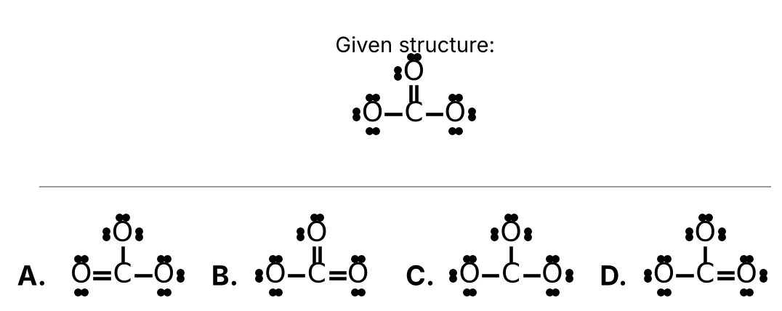
Choose A, B, C, or D from the figure.
14. You prepare an aqueous solution of sodium sulfide. Which of the following statements about this solution is correct?
A. The solvent is water and the solute is NaS.
B. The solvent is water and the solute is Na₂S.
C. The solvent is Na₂S and the solute is water.
D. The solvent is water and the solute is Na₂SO₄.
15. What volume of a 0.250 M NaOH solution contains 0.0500 moles of NaOH?
A. 0.0125 mL
B. 12.5 mL
C. 200. mL
D. 5.00 × 10³ mL
16. Use the solubility rules to determine which of the following compounds is soluble in water.
A. CaCO₃
B. Ba(OH)₂
C. AgCl
D. PbI₂
17. Kryllium (Ky) is a fictional non-metal that forms an acid with the formula HKy. What is the name of this compound?
A. Kryllic acid
B. Kryllous acid
C. Hydrokryllous acid
D. Hydrokryllic acid
18. Zorbium (Zb) is a fictional element that forms the polyatomic ion named zorbate with the formula ZbO₃⁻. What would be the name of the acid with the chemical formula HZbO?
A. Hypozorbous acid
B. Perzorbic acid
C. Zorbic acid
D. Zorbous acid
19. Which of the following, when dissolved in water, will create a strong electrolyte solution?
A. C₆H₁₂O₆
B. CH₃OH
C. CH₄
D. HCl
20. Consider the following chemical reaction:
N₂ (g) + 3 H₂ (g) → 2 NH₃ (g)
Which of the following statements about this reaction is incorrect?
A. The number of atoms is the same on both sides of the equation.
B. All of the reactants and products are gases.
C. N₂ and H₂ are reactants.
D. The number of molecules is the same on both sides of the equation.
21. Balance the following chemical equation:
P₄ (s) + O₂ (g) → P₄O₁₀ (s) (unbalanced)
How many atoms of oxygen are found on the reactant side when the equation is properly balanced?
A. 2
B. 5
C. 10
D. 20
22. Aluminum metal reacts with chlorine gas to produce aluminum chloride. Write a properly balanced chemical equation for this reaction. How many chlorine molecules are consumed in this reaction?
A. 1
B. 2
C. 3
D. 6
23. Consider the following chemical reaction:
2 HgO → 2 Hg + O₂
This reaction would be classified as a ____.
A. Single Displacement Reaction
B. Double Displacement Reaction
C. Synthesis (Combination) Reaction
D. Decomposition Reaction
24. Which of the following chemical reactions will not occur?
A. Al (s) + 3 AgNO₃ (aq) → Al(NO₃)₃ (aq) + 3 Ag (s)
B. Ca (s) + 2 H₂O (ℓ) → Ca(OH)₂ (aq) + H₂ (g)
C. Fe (s) + CuSO₄ (aq) → FeSO₄ (aq) + Cu (s)
D. 2 Ag (s) + Zn(NO₃)₂ (aq) → 2 AgNO₃ (aq) + Zn (s)
25. What are the products of the complete combustion of ethanol, C₂H₅OH?
A. CO₂, H₂O, and O₂
B. CO₂ and H₂O
C. CO₂ only
D. H₂O only

Answer Sheet — Day 2
Circle one letter per question.
# | Answer | # | Answer | # | Answer
1 | A B C D | 10 | A B C D | 19 | A B C D
2 | A B C D | 11 | A B C D | 20 | A B C D
3 | A B C D | 12 | A B C D | 21 | A B C D
4 | A B C D | 13 | A B C D | 22 | A B C D
5 | A B C D | 14 | A B C D | 23 | A B C D
6 | A B C D | 15 | A B C D | 24 | A B C D
7 | A B C D | 16 | A B C D | 25 | A B C D
8 | A B C D | 17 | A B C D
9 | A B C D | 18 | A B C D

